Modern Database Management, 13e (Hoffer)
Chapter 2 Modeling Data in the Organization

1) The logical representation of an organization's data is called a(n):
A) database model.
B) entity-relationship model.
C) relationship systems design.
D) database entity diagram.
Answer: B
LO: 2.1: Define key terms.
Difficulty: Easy
Classification: Concept
AACSB: Information Technology

2) A good data definition will describe all of the characteristics of a data object EXCEPT:
A) subtleties.
B) examples.
C) who determines the value of the data.
D) who can delete the data.
Answer: D
LO: 2.1: Define key terms.
Difficulty: Difficult
Classification: Concept
AACSB: Information Technology

3) A fact is an association between two or more:
A) words.
B) terms.
C) facts.
D) nuggets.
Answer: B
LO: 2.1: Define key terms.
Difficulty: Easy
Classification: Concept
AACSB: Information Technology

4) Data modeling may be the most important part of the systems development process because:
A) data characteristics are important in the design of programs and other systems components.
B) the data in a system are generally less complex than processes and play a central role in development.
C) data are less stable than processes.
D) it is the easiest.
Answer: A
LO: 2.2: State reasons why many system developers and business leaders believe that data modeling is the most important part of the systems development process with a high return on investment.
Difficulty: Easy
Classification: Concept
AACSB: Information Technology
5) The most common types of entities are:
A) strong entities.
B) weak entities.
C) associative entities.
D) smush entities.
Answer: A
LO: 2.3: Write good names and definitions for entities, relationships, and attributes.
Difficulty: Moderate
Classification: Concept
AACSB: Information Technology

6) In an E-R diagram, there are/is ________ business rule(s) for every relationship.
A) two
B) three
C) one
D) zero
Answer: A
LO: 2.3: Write good names and definitions for entities, relationships, and attributes.
Difficulty: Moderate
Classification: Concept
AACSB: Information Technology

7) Business policies and rules govern all of the following EXCEPT:
A) managing employees.
B) creating data.
C) updating data.
D) removing data.
Answer: A
LO: 2.3: Write good names and definitions for entities, relationships, and attributes.
Difficulty: Moderate
Classification: Concept
AACSB: Information Technology

8) A ________ defines or constrains some aspect of the business.
A) business constraint
B) business structure
C) business control
D) business rule
Answer: D
LO: 2.3: Write good names and definitions for entities, relationships, and attributes.
Difficulty: Moderate
Classification: Concept
AACSB: Information Technology
9) Which of the following is NOT a characteristic of a good business rule?
A) Declarative
B) Atomic
C) Inconsistent
D) Expressible
Answer: C
LO: 2.3: Write good names and definitions for entities, relationships, and attributes.
Difficulty: Moderate
Classification: Concept
AACSB: Information Technology

10) Which of the following is NOT a good characteristic of a data name?
A) Relates to business characteristics
B) Readable
C) Repeatable
D) Relates to a technical characteristic of the system
Answer: D
LO: 2.3: Write good names and definitions for entities, relationships, and attributes.
Difficulty: Moderate
Classification: Concept
AACSB: Information Technology

11) Customers, cars, and parts are examples of:
A) entities.
B) attributes.
C) cardinals.
D) relationships.
Answer: A
LO: 2.3: Write good names and definitions for entities, relationships, and attributes.
Difficulty: Moderate
Classification: Concept
AACSB: Information Technology

12) Which of the following is an entity that exists independently of other entity types?
A) Codependent
B) Weak
C) Strong
D) Variant
Answer: C
LO: 2.3: Write good names and definitions for entities, relationships, and attributes.
Difficulty: Moderate
Classification: Concept
AACSB: Information Technology
13) An entity type whose existence depends on another entity type is called a ________ entity.
A) strong
B) weak
C) codependent
D) variant
Answer: B
LO: 2.3: Write good names and definitions for entities, relationships, and attributes.
Difficulty: Moderate
Classification: Concept
AACSB: Information Technology

14) The following figure shows an example of:

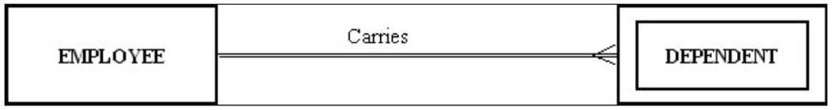

A) a one-to-many relationship.
B) a strong entity and its associated weak entity.
C) a co-dependent relationship.
D) a double-walled relationship.
Answer: B
LO: 2.3: Write good names and definitions for entities, relationships, and attributes.
Difficulty: Moderate
Classification: Application
AACSB: Information Technology, Application of Knowledge

15) A(n) ________ is the relationship between a weak entity type and its owner.
A) member chain
B) identifying relationship
C) jump path
D) chain link
Answer: B
LO: 2.3: Write good names and definitions for entities, relationships, and attributes.
Difficulty: Moderate
Classification: Concept
AACSB: Information Technology

16) An entity type name should be all of the following EXCEPT:
A) concise.
B) specific to the organization.
C) as short as possible.
D) a singular noun.
Answer: C
LO: 2.3: Write good names and definitions for entities, relationships, and attributes.
Difficulty: Moderate
Classification: Concept
AACSB: Information Technology
17) A property or characteristic of an entity type that is of interest to the organization is called a(n):
A) attribute.
B) coexisting entity.
C) relationship.
D) cross-function.
Answer: A
LO: 2.3: Write good names and definitions for entities, relationships, and attributes.
Difficulty: Easy
Classification: Concept
AACSB: Information Technology

18) An attribute that must be present for every entity (or relationship) instance is a(n):
A) composite attribute.
B) required attribute.
C) optional attribute.
D) multivalued attribute.
Answer: B
LO: 2.3: Write good names and definitions for entities, relationships, and attributes.
Difficulty: Easy
Classification: Concept
AACSB: Information Technology

19) A person's name, birthday, and social security number are all examples of:
A) attributes.
B) entities.
C) relationships.
D) descriptors.
Answer: A
LO: 2.3: Write good names and definitions for entities, relationships, and attributes.
Difficulty: Moderate
Classification: Concept
AACSB: Information Technology

20) An attribute of an entity that is computed is a(n):
A) optional attribute.
B) composite attribute.
C) derived attribute.
D) fuzzy attribute.
Answer: C
LO: 2.3: Write good names and definitions for entities, relationships, and attributes.
Difficulty: Moderate
Classification: Concept
AACSB: Information Technology
21) An attribute that can be broken down into smaller parts is called a(n) ________ attribute.
A) associative
B) simple
C) composite
D) complex
Answer: C
LO: 2.3: Write good names and definitions for entities, relationships, and attributes.
Difficulty: Easy
Classification: Concept
AACSB: Information Technology

22) The number of entity types that participate in a Unary relationship is:
A) zero.
B) one.
C) two.
D) three.
Answer: B
LO: 2.4: Distinguish unary, binary, and ternary relationships and give a common example of each.
Difficulty: Easy
Classification: Concept
AACSB: Information Technology

23) The number of entity types that participate in a relationship is called the:
A) number.
B) identifying characteristic.
C) degree.
D) counter.
Answer: C
LO: 2.4: Distinguish unary, binary, and ternary relationships and give a common example of each.
Difficulty: Easy
Classification: Concept
AACSB: Information Technology

24) A relationship between the instances of a single entity type is called a ________ relationship.
A) ternary
B) primary
C) binary
D) unary
Answer: D
LO: 2.4: Distinguish unary, binary, and ternary relationships and give a common example of each.
Difficulty: Moderate
Classification: Concept
AACSB: Information Technology
25) In the following diagram, what type of relationship is depicted?

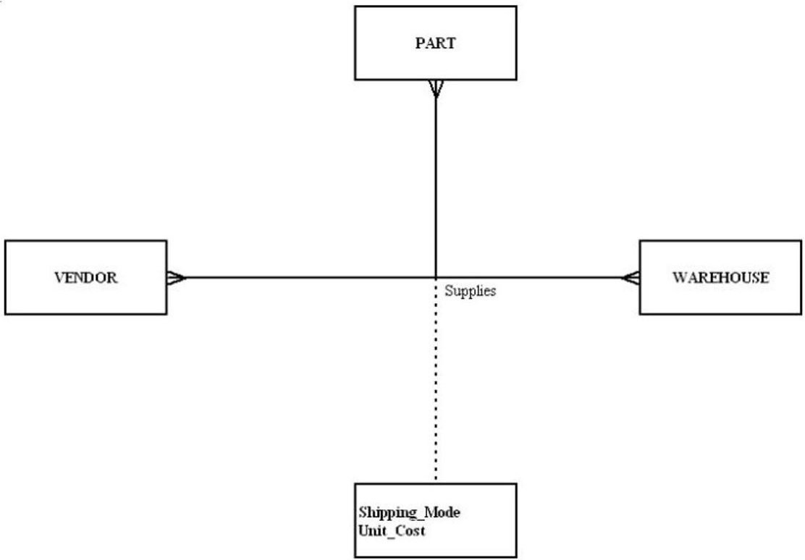

A) Unary
B) Binary
C) Ternary
D) Quad
Answer: C
LO: 2.4: Distinguish unary, binary, and ternary relationships and give a common example of each.
Difficulty: Moderate
Classification: Application
AACSB: Information Technology, Application of Knowledge
26) In the following diagram, which is true?

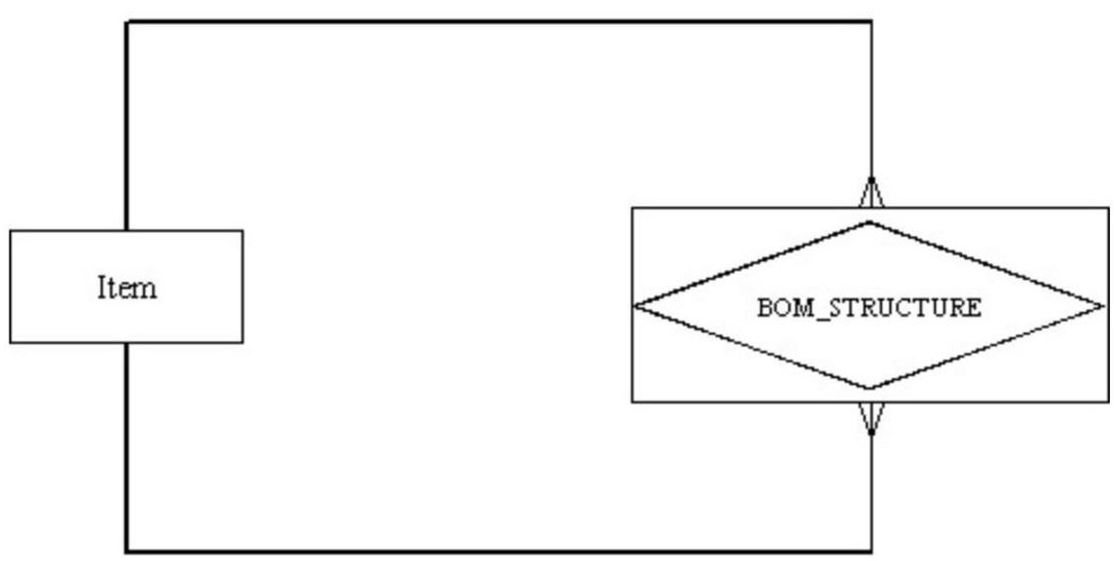

A) It depicts a ternary relationship.
B) It depicts a many-to-many relationship.
C) Item represents a column.
D) BOM_STRUCTURE represents a row.
Answer: B
LO: 2.4: Distinguish unary, binary, and ternary relationships and give a common example of each.
Difficulty: Difficult
Classification: Application
AACSB: Information Technology, Application of Knowledge

27) A simultaneous relationship among the instances of three entity types is called a ________ relationship.
A) ternary
B) tertiary
C) primary
D) binary
Answer: A
LO: 2.4: Distinguish unary, binary, and ternary relationships and give a common example of each.
Difficulty: Easy
Classification: Concept
AACSB: Information Technology
28) The following figure shows an example of:

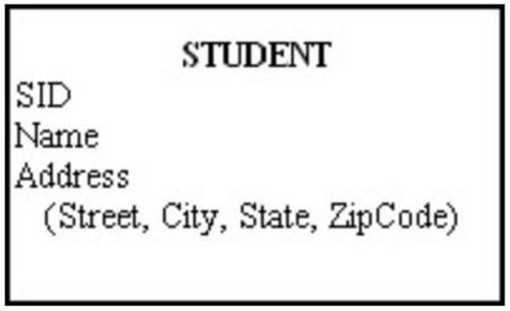

A) a composite attribute.
B) a relational attribute.
C) a derived attribute.
D) a multivalued attribute.
Answer: A
LO: 2.5: Model each of the following constructs in an E-R diagram: composite attribute, multivalued attribute, derived attribute, associative entity, identifying relationship, and minimum and maximum cardinality constraints.
Difficulty: Moderate
Classification: Application
AACSB: Information Technology, Application of Knowledge

29) In the figure below, which attribute is multivalued?

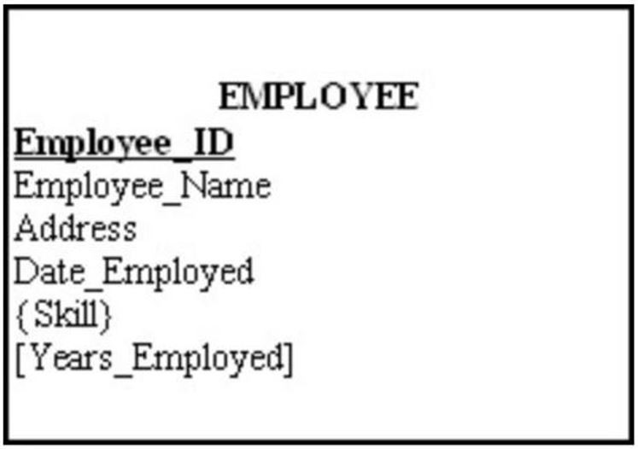

A) Years_Employed
B) Employee_ID
C) Skill
D) Address
Answer: C
LO: 2.5: Model each of the following constructs in an E-R diagram: composite attribute, multivalued attribute, derived attribute, associative entity, identifying relationship, and minimum and maximum cardinality constraints.
Difficulty: Moderate
Classification: Application
AACSB: Information Technology, Application of Knowledge
30) In the figure below, which attribute is derived?

A) Years_Employed
B) Employee_ID
C) Skill
D) Address
Answer: A
LO: 2.5: Model each of the following constructs in an E-R diagram: composite attribute, multivalued attribute, derived attribute, associative entity, identifying relationship, and minimum and maximum cardinality constraints.
Difficulty: Moderate
Classification: Application
AACSB: Information Technology, Application of Knowledge

31) An attribute that can be calculated from related attribute values is called a ________ attribute.
A) simple
B) composite
C) multivalued
D) derived
Answer: D
LO: 2.5: Model each of the following constructs in an E-R diagram: composite attribute, multivalued attribute, derived attribute, associative entity, identifying relationship, and minimum and maximum cardinality constraints.
Difficulty: Moderate
Classification: Concept
AACSB: Information Technology

32) The total quiz points for a student for an entire semester is a(n) ________ attribute.
A) derived
B) mixed
C) stored
D) addressed
Answer: A
LO: 2.5: Model each of the following constructs in an E-R diagram: composite attribute, multivalued attribute, derived attribute, associative entity, identifying relationship, and minimum and maximum cardinality constraints.
Difficulty: Easy
Classification: Concept
AACSB: Information Technology
33) Which of the following criteria should be considered when selecting an identifier?
A) Choose an identifier that is not stable.
B) Choose a null identifier.
C) Choose an identifier that doesn't have large composite attributes.
D) Choose the most complex identifier possible.
Answer: C
LO: 2.5: Model each of the following constructs in an E-R diagram: composite attribute, multivalued attribute, derived attribute, associative entity, identifying relationship, and minimum and maximum cardinality constraints.
Difficulty: Easy
Classification: Concept
AACSB: Information Technology

34) An attribute that uniquely identifies an entity and consists of a composite attribute is called a(n):
A) composite attribute.
B) composite identifier.
C) identifying attribute.
D) relationship identifier.
Answer: B
LO: 2.5: Model each of the following constructs in an E-R diagram: composite attribute, multivalued attribute, derived attribute, associative entity, identifying relationship, and minimum and maximum cardinality constraints.
Difficulty: Easy
Classification: Concept
AACSB: Information Technology

35) An entity that associates the instances of one or more entity types and contains attributes peculiar to the relationships is called a(n):
A) associative entity.
B) build entity.
C) gateway entity.
D) smush entity.
Answer: A
LO: 2.5: Model each of the following constructs in an E-R diagram: composite attribute, multivalued attribute, derived attribute, associative entity, identifying relationship, and minimum and maximum cardinality constraints.
Difficulty: Easy
Classification: Concept
AACSB: Information Technology

36) A ________ specifies the number of instances of one entity that can be associated with each instance of another entity.
A) degree
B) cardinality constraint
C) counter constraint
D) limit
Answer: B
LO: 2.5: Model each of the following constructs in an E-R diagram: composite attribute, multivalued attribute, derived attribute, associative entity, identifying relationship, and minimum and maximum cardinality constraints.
Difficulty: Easy
Classification: Concept
AACSB: Information Technology
37) A relationship where the minimum and maximum cardinality are both one is a(n) ________ relationship.
A) optional
B) unidirectional
C) mandatory link
D) mandatory one
Answer: D
LO: 2.5: Model each of the following constructs in an E-R diagram: composite attribute, multivalued attribute, derived attribute, associative entity, identifying relationship, and minimum and maximum cardinality constraints.
Difficulty: Moderate
Classification: Concept
AACSB: Information Technology

38) A mutually exclusive relationship is one in which:
A) an entity instance can participate in many different relationships.
B) an entity instance can participate in only one of several alternative relationships.
C) an entity instance cannot participate in a relationship with another entity instance.
D) an entity instance bridges other XML documents.
Answer: B
LO: 2.5: Model each of the following constructs in an E-R diagram: composite attribute, multivalued attribute, derived attribute, associative entity, identifying relationship, and minimum and maximum cardinality constraints.
Difficulty: Difficult
Classification: Concept
AACSB: Information Technology
39) In the figure shown below, which of the following is true?

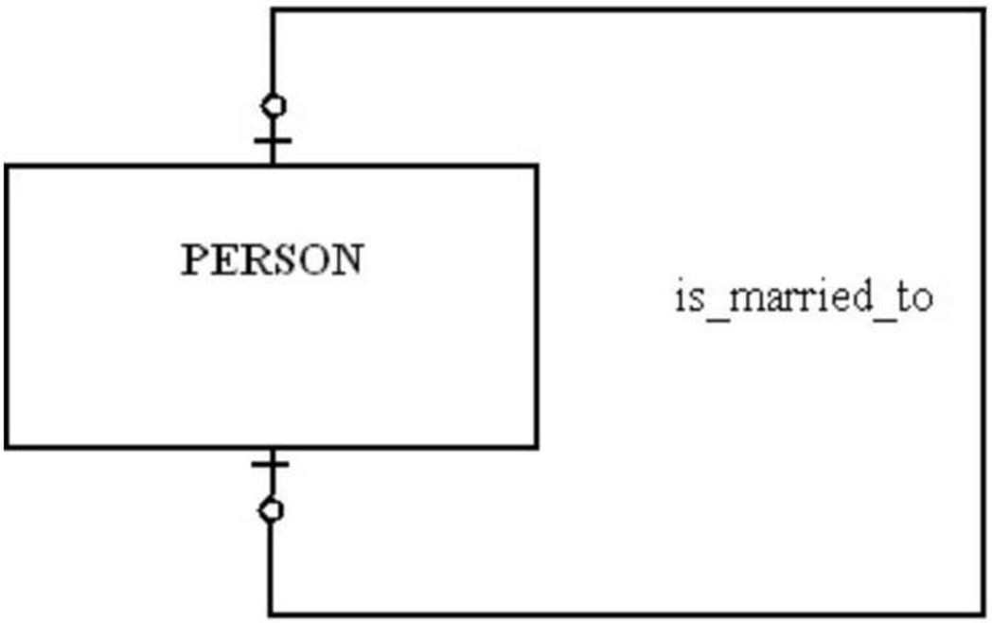

A) A person can marry at most one person.
B) A person has to be married.
C) A person can marry more than one person, but that person can only be married to one person.
D) A person can marry more than one person.
Answer: A
LO: 2.6: Draw an E-R diagram to represent common business situations.
Difficulty: Moderate
Classification: Application
AACSB: Information Technology, Application of Knowledge

40) For the relationship represented in the figure below, which of the following is true?

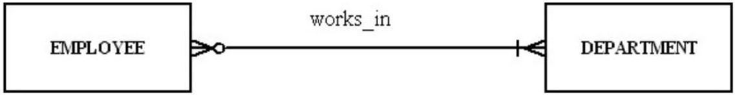

A) An employee can work in more than one department but does not have to work for any department.
B) A department must have at least one employee.
C) A department can have more than one employee.
D) An employee has to work for more than one department.
Answer: C
LO: 2.6: Draw an E-R diagram to represent common business situations.
Difficulty: Difficult
Classification: Application
AACSB: Information Technology, Application of Knowledge
41) In the following diagram, which of the answers below is true?

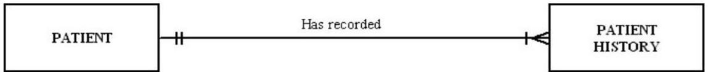

A) Each patient has one or more patient histories.
B) Each patient has one and only one visit.
C) Each patient history belongs to zero and one patient.
D) Each patient history belongs to many patients.
Answer: A
LO: 2.6: Draw an E-R diagram to represent common business situations.
Difficulty: Moderate
Classification: Application
AACSB: Information Technology, Application of Knowledge

42) In the figure shown below, which of the following business rules would apply?

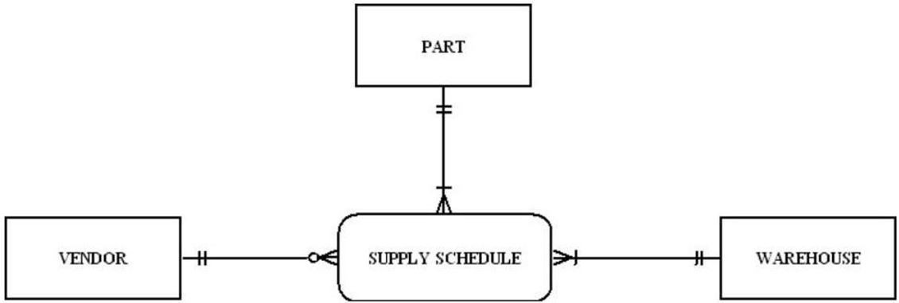

A) Each vendor can supply many parts to any number of warehouses, but need not supply any parts.
B) Each part must be supplied by exactly one vendor to any number of warehouses.
C) Each warehouse can be supplied with any number of parts from more than one vendor, and each warehouse could be supplied with no parts.
D) VENDOR is not allowed.
Answer: A
LO: 2.6: Draw an E-R diagram to represent common business situations.
Difficulty: Difficult
Classification: Application
AACSB: Information Technology, Application of Knowledge
43) In the following diagram, which answer is true?

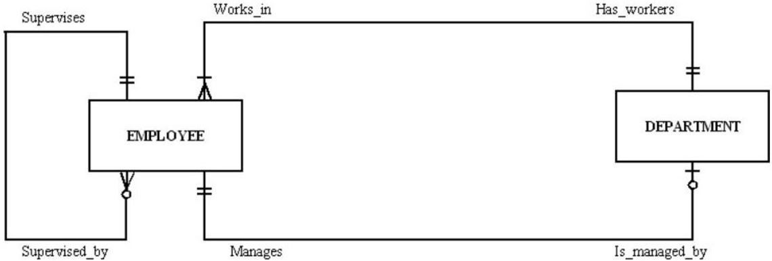

A) Each employee can supervise one employee, no employees, or many employees.
B) Each employee can manage many departments.
C) Each employee works in more than one department.
D) Each employee was fired.
Answer: A
LO: 2.6: Draw an E-R diagram to represent common business situations.
Difficulty: Difficult
Classification: Application
AACSB: Information Technology, Application of Knowledge
44) A student can attend five classes, each with a different professor. Each professor has 30 students. The relationship of students to professors is a ________ relationship.
A) one-to-one
B) many-to-many
C) one-to-many
D) strong
Answer: B
LO: 2.7: Convert a many-to-many relationship to an associative entity type.
Difficulty: Difficult
Classification: Concept
AACSB: Information Technology

45) A value that indicates the date or time of a data value is called a:
A) value stamp.
B) time stamp.
C) checkpoint.
D) check counter.
Answer: B
LO: 2.8: Model simple time-dependent data using time stamps and relationships in an E-R diagram.
Difficulty: Moderate
Classification: Concept
AACSB: Information Technology
46) The E-R model is used to construct a conceptual model.
Answer: TRUE
LO: 2.1: Define key terms.
Difficulty: Moderate
Classification: Concept
AACSB: Information Technology

47) A business rule is a statement that defines or constrains some aspect of the business.
Answer: TRUE
LO: 2.1: Define key terms.
Difficulty: Easy
Classification: Concept
AACSB: Information Technology

48) One of the roles of a database analyst is to identify and understand rules that govern data.
Answer: TRUE
LO: 2.1: Define key terms.
Difficulty: Easy
Classification: Concept
AACSB: Information Technology

49) The intent of a business rule is to break down business structure.
Answer: FALSE
LO: 2.1: Define key terms.
Difficulty: Easy
Classification: Concept
AACSB: Information Technology

50) Enforcement of business rules can be automated through the use of software that can interpret the rules and enforce them.
Answer: TRUE
LO: 2.1: Define key terms.
Difficulty: Moderate
Classification: Concept
AACSB: Information Technology

51) A business rule is a statement of how a policy is enforced or conducted.
Answer: FALSE
LO: 2.1: Define key terms.
Difficulty: Moderate
Classification: Concept
AACSB: Information Technology

52) While business rules are not redundant, a business rule can refer to another business rule.
Answer: TRUE
LO: 2.1: Define key terms.
Difficulty: Moderate
Classification: Concept
AACSB: Information Technology
53) A business rule should be internally consistent.
Answer: TRUE
LO: 2.1: Define key terms.
Difficulty: Easy
Classification: Concept
AACSB: Information Technology

54) Business rules are formulated from a collection of business ramblings.
Answer: FALSE
LO: 2.1: Define key terms.
Difficulty: Moderate
Classification: Concept
AACSB: Information Technology

55) Data names should always relate to business characteristics.
Answer: TRUE
LO: 2.1: Define key terms.
Difficulty: Easy
Classification: Concept
AACSB: Information Technology

56) An example of a term would be the following sentence: "A student registers for a course."
Answer: FALSE
LO: 2.1: Define key terms.
Difficulty: Difficult
Classification: Concept
AACSB: Information Technology

57) A fact is an association between two or more terms.
Answer: TRUE
LO: 2.1: Define key terms.
Difficulty: Easy
Classification: Concept
AACSB: Information Technology

58) A good data definition is always accompanied by diagrams, such as the entity-relationship diagram.
Answer: TRUE
LO: 2.1: Define key terms.
Difficulty: Easy
Classification: Concept
AACSB: Information Technology

59) An entity is a person, place, object, event, or concept in the user environment about which the organization wishes to maintain data.
Answer: TRUE
LO: 2.1: Define key terms.
Difficulty: Easy
Classification: Concept
AACSB: Information Technology
60) A single occurrence of an entity type is called an entity instance.
Answer: TRUE
LO: 2.1: Define key terms.
Difficulty: Moderate
Classification: Concept
AACSB: Information Technology

61) In the figure below, Name would be an ideal identifier.

Answer: FALSE
LO: 2.1: Define key terms.
Difficulty: Difficult
Classification: Application
AACSB: Information Technology, Application of Knowledge

62) When choosing an identifier, choose one that will not change its value often.
Answer: TRUE
LO: 2.1: Define key terms.
Difficulty: Easy
Classification: Concept
AACSB: Information Technology

63) Most systems developers believe that data modeling is the least important part of the systems development process.
Answer: FALSE
LO: 2.2: State reasons why many system developers and business leaders believe that data modeling is the most important part of the systems development process with a high return on investment.
Difficulty: Moderate
Classification: Concept
AACSB: Information Technology

64) Data, rather than processes, are the most complex aspects of many modern information systems.
Answer: TRUE
LO: 2.2: State reasons why many system developers and business leaders believe that data modeling is the most important part of the systems development process with a high return on investment.
Difficulty: Moderate
Classification: Concept
AACSB: Information Technology
65) Data modeling is about documenting rules and policies of an organization that govern data.
Answer: TRUE
LO: 2.2: State reasons why many system developers and business leaders believe that data modeling is the most important part of the systems development process with a high return on investment.
Difficulty: Moderate
Classification: Concept
AACSB: Information Technology

66) The purpose of data modeling is to document business rules about processes.
Answer: FALSE
LO: 2.2: State reasons why many system developers and business leaders believe that data modeling is the most important part of the systems development process with a high return on investment.
Difficulty: Moderate
Classification: Concept
AACSB: Information Technology

67) In an E-R diagram, strong entities are represented by double-walled rectangles.
Answer: FALSE
LO: 2.3: Write good names and definitions for entities, relationships, and attributes.
Difficulty: Moderate
Classification: Concept
AACSB: Information Technology

68) In an E-R diagram, an associative entity is represented by a rounded rectangle.
Answer: TRUE
LO: 2.3: Write good names and definitions for entities, relationships, and attributes.
Difficulty: Moderate
Classification: Concept
AACSB: Information Technology

69) Data names do not have to be unique.
Answer: FALSE
LO: 2.3: Write good names and definitions for entities, relationships, and attributes.
Difficulty: Moderate
Classification: Concept
AACSB: Information Technology

70) The relationship between a weak entity type and its owner is an identifying relationship.
Answer: TRUE
LO: 2.3: Write good names and definitions for entities, relationships, and attributes.
Difficulty: Easy
Classification: Concept
AACSB: Information Technology

71) An entity type on which a strong entity is dependent is called a covariant entity.
Answer: FALSE
LO: 2.3: Write good names and definitions for entities, relationships, and attributes.
Difficulty: Moderate
Classification: Concept
AACSB: Information Technology
72) An entity type name should always be a singular noun.
Answer: TRUE
LO: 2.3: Write good names and definitions for entities, relationships, and attributes.
Difficulty: Easy
Classification: Concept
AACSB: Information Technology

73) The name used for an entity type should never be the same in other E-R diagrams on which the entity appears.
Answer: FALSE
LO: 2.3: Write good names and definitions for entities, relationships, and attributes.
Difficulty: Moderate
Classification: Concept
AACSB: Information Technology

74) Some examples of attributes are: eye_color, weight, student_id, STUDENT.
Answer: FALSE
LO: 2.3: Write good names and definitions for entities, relationships, and attributes.
Difficulty: Moderate
Classification: Concept
AACSB: Information Technology

75) A simple attribute can be broken down into smaller pieces.
Answer: FALSE
LO: 2.3: Write good names and definitions for entities, relationships, and attributes.
Difficulty: Moderate
Classification: Concept
AACSB: Information Technology

76) An attribute whose values can be calculated from related attribute values is called a derived attribute.
Answer: TRUE
LO: 2.3: Write good names and definitions for entities, relationships, and attributes.
Difficulty: Easy
Classification: Concept
AACSB: Information Technology

77) A multivalued attribute may take on more than one value for a particular entity instance.
Answer: TRUE
LO: 2.3: Write good names and definitions for entities, relationships, and attributes.
Difficulty: Easy
Classification: Concept
AACSB: Information Technology

78) Relationships represent action being taken using a verb phrase.
Answer: TRUE
LO: 2.3: Write good names and definitions for entities, relationships, and attributes.
Difficulty: Moderate
Classification: Concept
AACSB: Information Technology
79) Participation in a relationship may be optional or mandatory.
Answer: TRUE
LO: 2.3: Write good names and definitions for entities, relationships, and attributes.
Difficulty: Moderate
Classification: Concept
AACSB: Information Technology

80) A ternary relationship is equivalent to three binary relationships.
Answer: FALSE
LO: 2.4: Distinguish unary, binary, and ternary relationships and give a common example of each.
Difficulty: Moderate
Classification: Concept
AACSB: Information Technology

81) The degree of a relationship is the number of attributes that are associated with it.
Answer: FALSE
LO: 2.4: Distinguish unary, binary, and ternary relationships and give a common example of each.
Difficulty: Easy
Classification: Concept
AACSB: Information Technology

82) The relationship between the instances of two entity types is called a binary relationship.
Answer: TRUE
LO: 2.4: Distinguish unary, binary, and ternary relationships and give a common example of each.
Difficulty: Easy
Classification: Concept
AACSB: Information Technology

83) The relationship among the instances of three entity types is called a unary relationship.
Answer: FALSE
LO: 2.4: Distinguish unary, binary, and ternary relationships and give a common example of each.
Difficulty: Easy
Classification: Concept
AACSB: Information Technology

84) It is desirable that no two attributes across all entity types have the same name.
Answer: TRUE
LO: 2.5: Model each of the following constructs in an E-R diagram: composite attribute, multivalued attribute, derived attribute, associative entity, identifying relationship, and minimum and maximum cardinality constraints.
Difficulty: Moderate
Classification: Concept
AACSB: Information Technology

85) It is not permissible to associate attributes with relationships.
Answer: FALSE
LO: 2.5: Model each of the following constructs in an E-R diagram: composite attribute, multivalued attribute, derived attribute, associative entity, identifying relationship, and minimum and maximum cardinality constraints.
Difficulty: Moderate
Classification: Concept
AACSB: Information Technology
86) A relationship instance is an association between entity instances where each relationship instance includes exactly one entity from each participating entity type.
Answer: FALSE
LO: 2.5: Model each of the following constructs in an E-R diagram: composite attribute, multivalued attribute, derived attribute, associative entity, identifying relationship, and minimum and maximum cardinality constraints.
Difficulty: Easy
Classification: Concept
AACSB: Information Technology

87) One reason to use an associative entity is if the associative entity has one or more attributes in addition to the identifier.
Answer: TRUE
LO: 2.5: Model each of the following constructs in an E-R diagram: composite attribute, multivalued attribute, derived attribute, associative entity, identifying relationship, and minimum and maximum cardinality constraints.
Difficulty: Easy
Classification: Concept
AACSB: Information Technology

88) In the figure below, the name of the relationship follows the guidelines for naming a relationship.

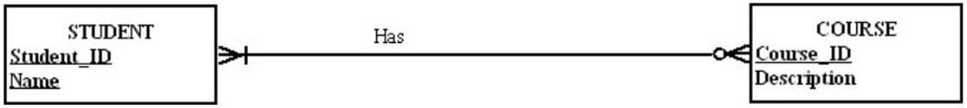
Answer: FALSE
LO: 2.5: Model each of the following constructs in an E-R diagram: composite attribute, multivalued attribute, derived attribute, associative entity, identifying relationship, and minimum and maximum cardinality constraints.
Difficulty: Moderate
Classification: Application
AACSB: Information Technology, Application of Knowledge

89) A cardinality constraint tells what kinds of properties are associated with an entity.
Answer: FALSE
LO: 2.5: Model each of the following constructs in an E-R diagram: composite attribute, multivalued attribute, derived attribute, associative entity, identifying relationship, and minimum and maximum cardinality constraints.
Difficulty: Easy
Classification: Concept
AACSB: Information Technology

90) The maximum criminality of a relationship is the maximum number of instances of entity B that may be associated with each instance of entity A.
Answer: FALSE
LO: 2.5: Model each of the following constructs in an E-R diagram: composite attribute, multivalued attribute, derived attribute, associative entity, identifying relationship, and minimum and maximum cardinality constraints.
Difficulty: Easy
Classification: Concept
AACSB: Information Technology
91) In the figure shown below, a person has to be married.

Answer: FALSE
LO: 2.6: Draw an E-R diagram to represent common business situations.
Difficulty: Moderate
Classification: Application
AACSB: Information Technology, Application of Knowledge

92) For the relationship represented in the figure below, a department can have more than one employee.

Answer: TRUE
LO: 2.6: Draw an E-R diagram to represent common business situations.
Difficulty: Difficult
Classification: Application
AACSB: Information Technology, Application of Knowledge

93) A customer can order many items, and an item can be ordered by many customers is an example of a recursive relationship.
Answer: FALSE
LO: 2.7: Convert a many-to-many relationship to an associative entity type.
Difficulty: Moderate
Classification: Application
AACSB: Information Technology

94) A time stamp is a time value that is associated with a data value.
Answer: TRUE
LO: 2.8: Model simple time-dependent data using time stamps and relationships in an E-R diagram.
Difficulty: Moderate
Classification: Concept
AACSB: Information Technology
95) On what premises are business rules based?
Answer: A business rules approach is based on the following:
1. Because business rules are an expression of business policy, they are a core concept in an enterprise.
2. Natural language for end-users and a data model for developers can be used to state business rules.
LO: 2.1: Define key terms.
Difficulty: Moderate
Classification: Synthesis
AACSB: Information Technology

96) What is the difference between an entity type and an entity instance?
Answer: An entity type is a collection of entities that share common properties. An entity instance is a single occurrence of an entity type. So, for example, STUDENT is an entity type and John Smith is an entity instance.
LO: 2.1: Define key terms.
Difficulty: Easy
Classification: Synthesis
AACSB: Reflective Thinking

97) How is a strong entity different from a weak entity?
Answer: A strong entity type exists independently of any other entities. A weak entity type depends on another (strong) entity type. When an instance of the strong entity type no longer exists, any weak entity instances which depend upon the strong entity cease to exist.
LO: 2.1: Define key terms.
Difficulty: Moderate
Classification: Synthesis
AACSB: Reflective Thinking

98) What is the difference between a simple attribute and a composite attribute?
Answer: A simple attribute cannot be broken down into smaller components, whereas a composite attribute can be. An example of a simple attribute is last name. An example of a composite attribute is mailing address, which would have street, city, state and zip code as components.
LO: 2.1: Define key terms.
Difficulty: Moderate
Classification: Synthesis
AACSB: Reflective Thinking

99) What is a derived attribute, and how is it different from a stored attribute?
Answer: A derived attribute is an attribute whose value can be calculated from other related attributes. A derived attribute is not stored in the physical table which is eventually created from the ERD. A stored attribute, as its name implies, is stored as a column in the physical table.
LO: 2.1: Define key terms.
Difficulty: Moderate
Classification: Synthesis
AACSB: Information Technology
100) What are some of the guidelines for good data names of objects in general?
Answer: Data names always should:
1. Relate to the business, not technical characteristics. Student would be a good name but not filest023
2. Be meaningful so that the name tells what the object is about
3. Be unique
4. Be readable
5. Be composed of words taken from an approved list
6. Be repeatable
7. Follow a standard syntax
LO: 2.3: Write good names and definitions for entities, relationships, and attributes.
Difficulty: Moderate
Classification: Synthesis
AACSB: Information Technology

101) What are the three different degrees of relationship?
Answer: The three possible degrees are: Unary (an instance of one entity is related to an instance of the same entity type), Binary (an entity instance of one type is related to an entity instance of another type), and Ternary (instance of three different types participate in a relationship).
LO: 2.4: Distinguish unary, binary, and ternary relationships and give a common example of each.
Difficulty: Moderate
Classification: Synthesis
AACSB: Information Technology

102) What is an associative entity? What four conditions should exist in order to convert a relationship to an associative entity?
Answer: An associative entity is an entity type that associates the instances of one or more entity types and contains attributes that are peculiar to the relationship between those entity instances. Often, a many-to-many relationship is converted to an associative entity. The following four conditions should exist in order to do this:
1. All the relationships for the participating entities types are many relationships.
2. The resulting associative entity has independent meaning.
3. The associative entity has one or more attributes other than the identifier.
4. The associative entity participates in one or more relationships independent of the entities in the associative relationship.
LO: 2.7: Convert a many-to-many relationship to an associative entity type.
Difficulty: Moderate
Classification: Synthesis
AACSB: Information Technology

